2021BUSINESS INVESTOR FORM
Business Name: __________________________ Contact Person: _______________________________ Business Phone: _______________________ Cell Phone: ______________________________________ Address: _______________________________________________________________________________ Email: ________________________________
Please choose from the following investor levels for the new Chamber-Main Street Business Investor levels - Valid July 1, 2021 - June 30, 2022.
❏ “Friend” $100
❏ “Advocate” $250
❏ “Associate” $500
❏ “Partner” $1,000
❏ “Champion” $2,000
Business Investment $_______
Friend Level $100
100% Tax Deductible
Usage of Community Calendar
Listed as a business in our business directory on the website
Participation in Chamber-Bucks program
Advocate Level $250
Includes all Friend benefits
Annual business spotlight
Logo on annual banner (payment must be received by August 1, 2021 to be on annual banner)
Participation in Table Tent program
Participation in Grundy Goodness Bundles

Associate Level $500
Includes all Friend and Advocate benefits
Additional social media shares promoting business
Eligible to apply for GCCMS “One Small Step” grant (up to $1,000 value)
Partner Level $1,000
Includes all Friend, Advocate, and Associate benefits
Priority referrals (services, rentals, food, etc.)
Placement in promotional materials
Champion Level $2,000
Includes all Friend, Advocate, Associate and Partner benefits
Social media video/business promotion video

EVENT SPONSORSHIP OPPORTUNITIES (in addition to initial investment)
❏ Yes, I’d like to be an event sponsor!
❏ Business Seminar - $250
❏ Celebration of Ag Event - $500
❏ Historic Preservation Month - $100
❏ Rock Around Clock Tower - $500
❏ Spring/Fall Clean-Up Days - $250
❏ Girl’s Getaway - $500
❏ Main Street Mingle - $500
❏ Small Business Saturday - $500
❏ Contact As Needed

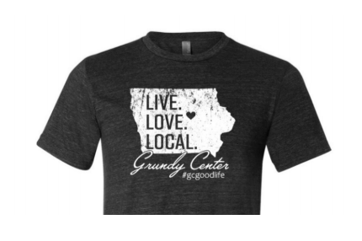
Event Sponsorship(s) $_______
+
Business Investment $_______
+
$25 Tee Shirt/ $30 Black Tumbler or Both $_______/ Size_____
($2 extra for 2X and up)
=
Total Contribution $_____________

THANK YOU for Investing in GCCMS!
Please Make Checks Payable and Return This Business Investor Form To: Grundy Center Chamber-Main Street
703 F. Ave, Grundy Center, Iowa 50638
For your logo to be on our annual banner, please make payments by August 1, 2021.

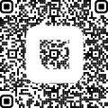
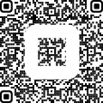

Investor Payment QR Code Shirt/Tumbler Payment QR Code

